Skill MAtcher

Full Stack Developer Course Project

Contents

Requirements 2

Features 2

Roles 2

1. User 2

2. HR 2

3. Admin 2

Use cases 3

Optional use cases 4

Ux design 5

5

# Requirements

Skill Matcher Multi user web application – each user has its own profile User can easily add to own portfolio certain skills (from variety of full stack layers and/or tools).

# Features

The application should create an environment including job candidates and HR. In general the application will provide interface between job candidates and HR department with these basic features:

* Create user profile
* Add skills with
  + Appropriate level of user
  + Time he was gaining experiences for it
* Match with users with current offers
* Search among users according to set skills and levels
* Adding new skills to better match with real world

# Roles

1. User – person with profile in the system where he or she has filled in all of his skillsets with corresponding levels and working experiences.

Actions:

* + Log-in
  + Create account
  + Create/edit profile
  + Suggest to create new skills (tags)
  + Optional:
    - Set himself as available (for position)
    - Match his skills with current positions
    - Responds to positions

1. HR – person from HR department who can manage job offers and match users according to their skills and contact them in case of match.

Actions:

* Log-in
* Look through users’ profiles
* Filter users according to set skills
* Create new skills (tags)
* Approve suggested skills
* Create statistics
* Optional:
  + Create positions with requirements

1. Admin – overall admin of the system. As the part of system management is delegated to the HR user admin’s duties are reduced.

Actions:

* Log-in
* Create HR user

# Use cases

|  |  |
| --- | --- |
| **Title** | **User/admin logs in** |
| **Goal** | Log in to profile/dashboard page |
| **Actor** | User, HR, Admin |
| **Story** | User logs in to his account |

|  |  |
| --- | --- |
| **Title** | **User creates account** |
| **Goal** | Create user’s account and get access to the system |
| **Actor** | User |
| **Story** | User registers to the system and confirms |

|  |  |
| --- | --- |
| **Title** | **User creates/edits profile** |
| **Goal** | Fill in his skills with levels and experience |
| **Actor** | User |
| **Story** | User adds skills, their levels and working experience (optional) |

|  |  |
| --- | --- |
| **Title** | **User suggests new skill** |
| **Goal** | Create new tag for skill which user didn’t find in the skills database |
| **Actor** | User |
| **Story** | If user cannot find the skill tag for the skill he is experienced with he can create new one, but this skill needs to be confirmed by someone from HR department, but still will be shown |

|  |  |
| --- | --- |
| **Title** | **HR looks through users profiles** |
| **Goal** | Have an overview of currently available users and their skills |
| **Actor** | HR |
| **Story** | HR can look through user profiles by skills, date of profile creation of recent updates in profiles |

|  |  |
| --- | --- |
| **Title** | **HR filters users according to skills** |
| **Goal** | Find suitable job candidates among user profiles with specific skills |
| **Actor** | HR |
| **Story** | HR can set the filter of user’s profiles by skills, their level and working experience and show them from most to least suitable |

|  |  |
| --- | --- |
| **Title** | **HR creates new skills (tags)** |
| **Goal** | To extend the actual skill database with new ones |
| **Actor** | HR |
| **Story** | HR will create a new skill tags in order to match better with current trends |

|  |  |
| --- | --- |
| **Title** | **HR approves suggested skills (tags)** |
| **Goal** | Approve (and create) new skill tags |
| **Actor** | HR |
| **Story** | HR approve suggested skill from user (if user cannot find skill which he has experiences with he can suggest it) and add it to current skill database |

|  |  |
| --- | --- |
| **Title** | **HR creates overview statistics** |
| **Goal** | Get an overall overview on current skills of registered users |
| **Actor** | HR |
| **Story** | HR will set the filter for the required skills and see the statistics of matched user profiles in a compact view |

|  |  |
| --- | --- |
| **Title** | **Create new HR user** |
| **Goal** | New HR user account is successfully created |
| **Actor** | Admin |
| **Story** | When new HR user is needed in the system (e.g. new employee at HR department), admin of the application creates this account. |

## Optional use cases

|  |  |
| --- | --- |
| **Title** | **User sets himself as available** |
| **Goal** | Let to know HR department that user is free for position |
| **Actor** | User |
| **Story** | User set his account as currently available so he can be contacted by HR department |

|  |  |
| --- | --- |
| **Title** | **User matches his skills** |
| **Goal** | Find offered position by HR according to user’s skills |
| **Actor** | User |
| **Story** | User is automatically matched with current best suiting positions according |

|  |  |
| --- | --- |
| **Title** | **User responds to matched jobs** |
| **Goal** | Connect user with opened position offer |
| **Actor** | User |
| **Story** | Match potentially suited available user to opened position |

|  |  |
| --- | --- |
| **Title** | **HR creates positions with requirements** |
| **Goal** | Create position which can be seen by users and let them know that new offer is available |
| **Actor** | HR |
| **Story** | If there is new available job offer HR can create it with appropriate requirements and with set of skills which are a MUST for the position |

# Ux design

# 

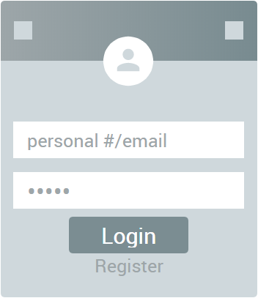

Register

Successful Login

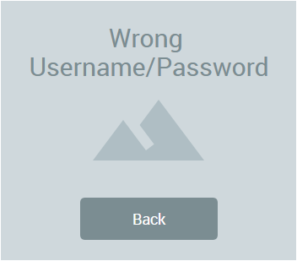

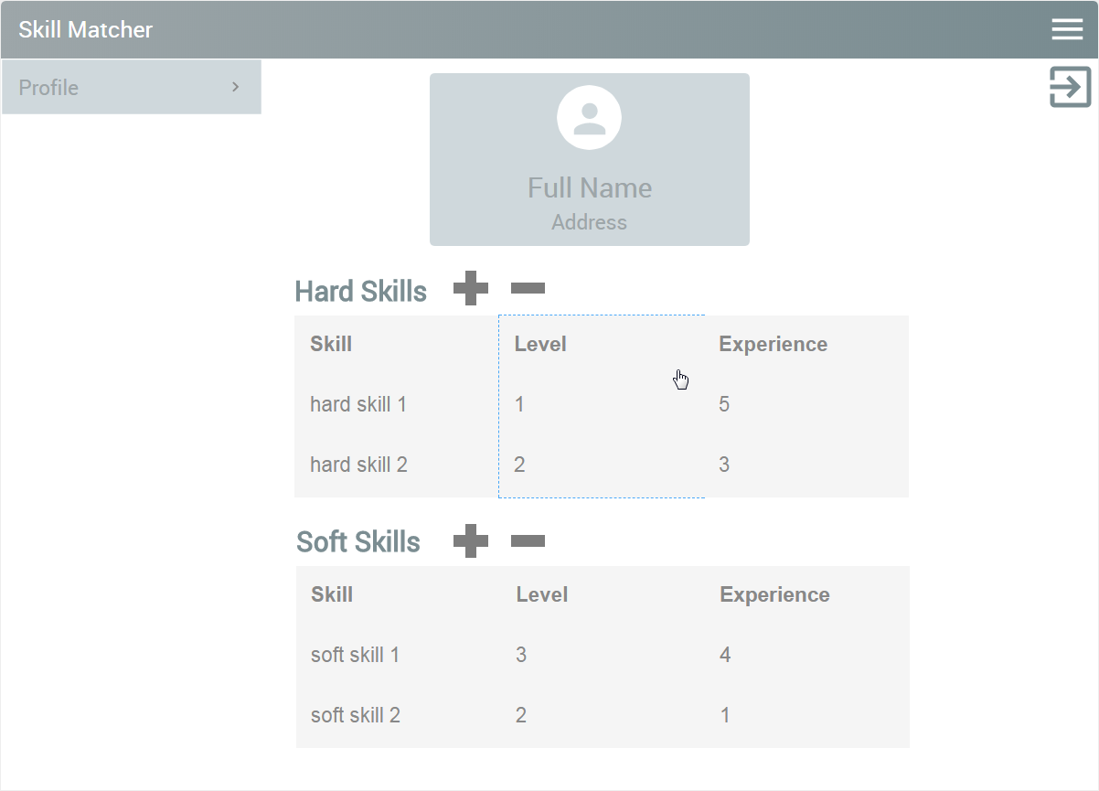

All User Types

Login Error

HR Users

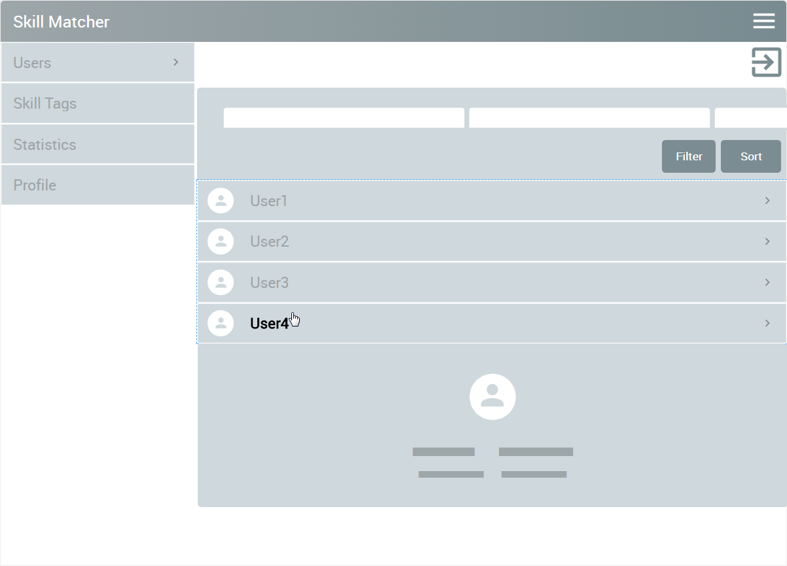

HR Users

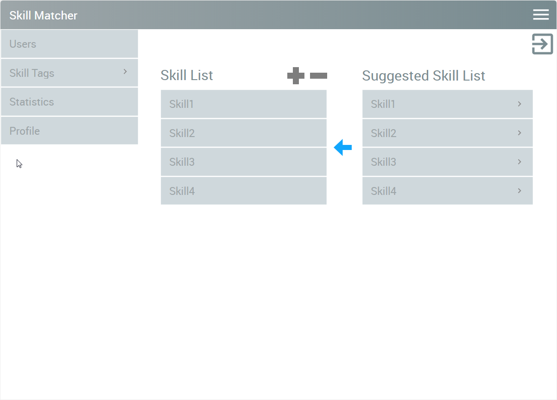

HR Users/Admins

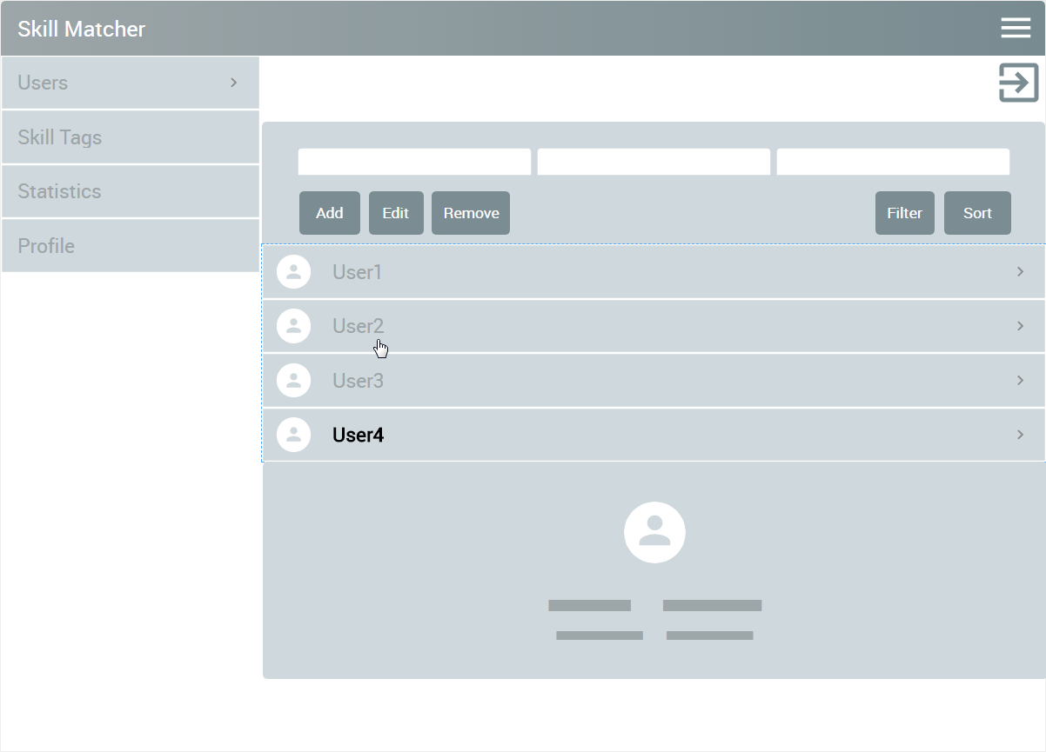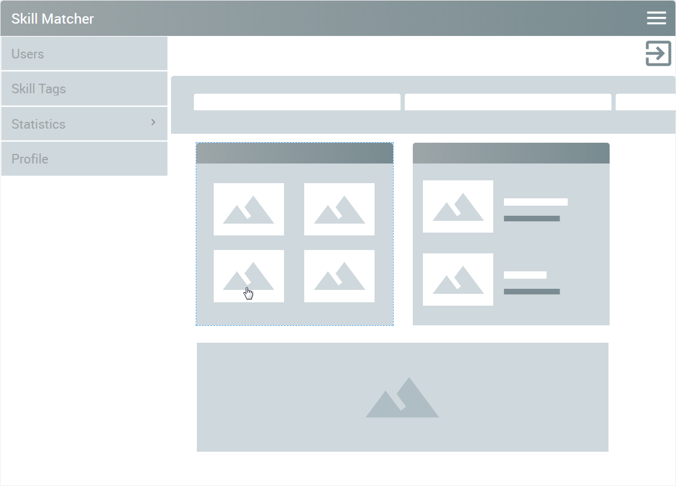

Admins

HR Users/Admins